l  


CISAC

ISWC Data Model

# Document Control

## Change Record

|  |  |  |
| --- | --- | --- |
| Date | Person | Version/Reference |
| 25th Feb 2019 | Curnan Reidy | Initial version |
| 1st Mar 2019 | Curnan Reidy | First Draft completed |
|  |  |  |

## Reviewers

Stephen Rollins

Peter Klauser

Sylvain Masson

Ed Osanani

Cynthia Lipskier

Vincent Poulain

Henk Dekker

Didier Roy

Hanna Mazur

José Macarro

Sylvain Piat

John Corley

## Distribution

Reviewers

## Approval

This document was approved electronically via email by the following people on the following dates:

|  |  |  |
| --- | --- | --- |
| Date/Time | Person | Note |
|  |  |  |

# Table of Contents

Document Control 2

Change Record 2

Reviewers 2

Distribution 2

Approval 2

Table of Contents 4

1. Introduction 6

What does this document contain? 6

Who should read this document? 6

Glossary 6

References 6

1. Overview 7
   1. Design goals for the new ISWC data model 7
   2. Database Schemas 7
   3. Database Technology 7
   4. Non-functional characteristics 8
      1. Scalability 8
         1. Core matching and validation 8
         2. Scaling for large data volumes 8
      2. Backup and recovery 8
      3. Access control 9
      4. Scheduled maintenance 9
2. ISWC Schema 10
   1. Work 11
   2. ISWC 11
   3. WorkInfo 12
   4. Title 13
   5. DisambiguationISWC 14
   6. Contributor 15
   7. Performer 16
   8. WorkInfoPerformer 17
3. IPI Schema 18
   1. InterestedParty 18
   2. Agreement 19
   3. Name 20
   4. IPNameUsage 20
   5. NameReference 21
   6. Status 21
4. Lookup Schema 22
   1. ContributorRoleType 22
   2. CisacContributorRoleMapping 23
   3. DisambiguationReason 23
   4. MatchType 24
   5. Society 24
   6. TitleType 24
   7. User 25
5. Audit Schema 26
   1. Audit 26
   2. AuditRequest 27
   3. AuditRequestTransaction 29
      1. AuditRequestTransactionError object definition 31
      2. AuditRequestWork object definition 31
6. ISWC (Cosmos DB) 33
   1. ISWC 33
7. Matching Engine Schema 34
   1. Azure Search Indices 34
      1. Work Numbers 34
      2. Work Name, Contributors, Performers 34
   2. Matching Settings Database 35

Appendix A – Open and Closed Items 36

1. Introduction

## What does this document contain?

It provides a detailed specification of the ISWC data model. We expect that the design of the data model will evolve as we work through the next work packages, however this document will give a solid foundation of what the overall design of the data model will be.

## Who should read this document?

CISAC development and project management personnel. Spanish Point development team members.

## Glossary

## References

|  |  |
| --- | --- |
| Reference | Description |
| <https://docs.microsoft.com/en-us/azure/cosmos-db> | Cosmos DB – based on MongoDB |
| <https://docs.microsoft.com/en-us/azure/search> | Azure Search – based on Lucene |
| <https://www.mongodb.com/what-is-mongodb> | MongoDB |
| <http://lucene.apache.org/> | Lucene |
| <https://azure.microsoft.com/en-us/services/key-vault/> | Azure Key Vault |

1. Overview

This chapter provides an overview of the Data Model for ISWC.

## Design goals for the new ISWC data model

The design goals for the ISWC data model are as follows:

* New disambiguation data is accommodated to enable more accurate work matching
* The Audit tables are stored in a more scalable way using Cosmos DB
* Azure Search is used to facilitate scalable matching

## Database Schemas

The following are the database schemas that will comprise the new data model:

* ISWC
* IPI
* Lookup
* Audit
* ISWC (Cosmos DB)
* Azure Search Indices
* Matching Settings database

## Database Technology

The main ISWC database will use two Azure SQL databases – a Primary node and a Secondary read-only replica.

The Audit records will be stored in an Azure Cosmos DB database. Azure Cosmos DB is a globally distributed NoSQL database service which is based on MongoDB.

Azure Search will be used to store the search indices used by the Matching Engine. Azure Search is a search service providing scalable full text search and querying capability that is based on Apache Lucene. The data for these indices will be continuously synchronized from the main Azure SQL database

## Non-functional characteristics

### Scalability

#### Core matching and validation

All core submission matching and validation will be carried out against Azure Search indices which are horizontally scalable.

#### Scaling for large data volumes

The data volumes for the ISWC, IPI and Lookup schemas are well within the data volumes that can be handled by a RDBMS. Log data, however, currently has 822 million rows in the existing database and has had to be manually partitioned across multiple tables for performance and maintenance reasons. In the new solution this audit data will be stored in Cosmos DB using the Society Code and Created Date as a partition key.

**Initial configuration of SQL Server**

* Managed instance of Azure SQL Server. This will be initially configured as a Gen 5 Business Critical database (vCore 24, Memory 122.4 GB)
* Secondary read-only replica will be used for read-only workloads
* Set number of DTUs that can be scaled up and down based on peak workloads and quiet periods.

**Initial config of Cosmos DB**

* An initial value of 1,000 RU (Request Units) will be provisioned.

Note: The config settings will be finalized during the UAT and Integration Testing parts of the project.

### Backup and recovery

The following backup strategies will be implemented:

* Azure SQL Databases
  + An automated backup is taken for the Azure SQL databases every 12 hours and transaction log backups every 5-10 minutes. The retention policy for these backups is 35 days. The restoration of the database can be done through the Azure portal in the event of any issues.
* Cosmos DB
  + Azure Cosmos DB automatically takes a backup of the database every 4 hours and at any one point in time, only the latest 2 backups are stored. For recovery within the 8 hours, Azure support will be contacted to restore the data from backup.
* Azure Search
  + Azure do not provide a backup service for Azure Search. If an issue occurs, we can recreate the Azure Search indices from the main ISWC database.

### Access control

The following diagram shows the physical architecture of the data model.

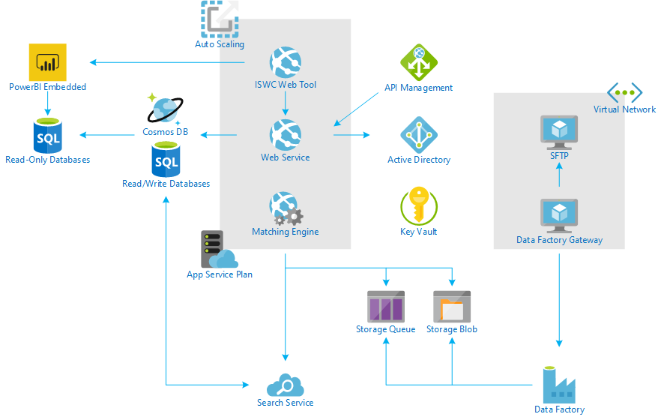

Azure Key Vault will be used to store connection strings and credentials needed to connect to each database.

### Scheduled maintenance

Scheduled SQL maintenance tasks will be automated via Azure Automation. This will allow index maintenance stored procedures to be executed on a scheduled basis. These maintenance tasks are as follows:

* Index optimization on a weekly basis
* Update statistics on all tables daily

1. ISWC Schema

The ISWC schema contains the core ISWC tables. The following is an ER diagram for the ISWC schema:

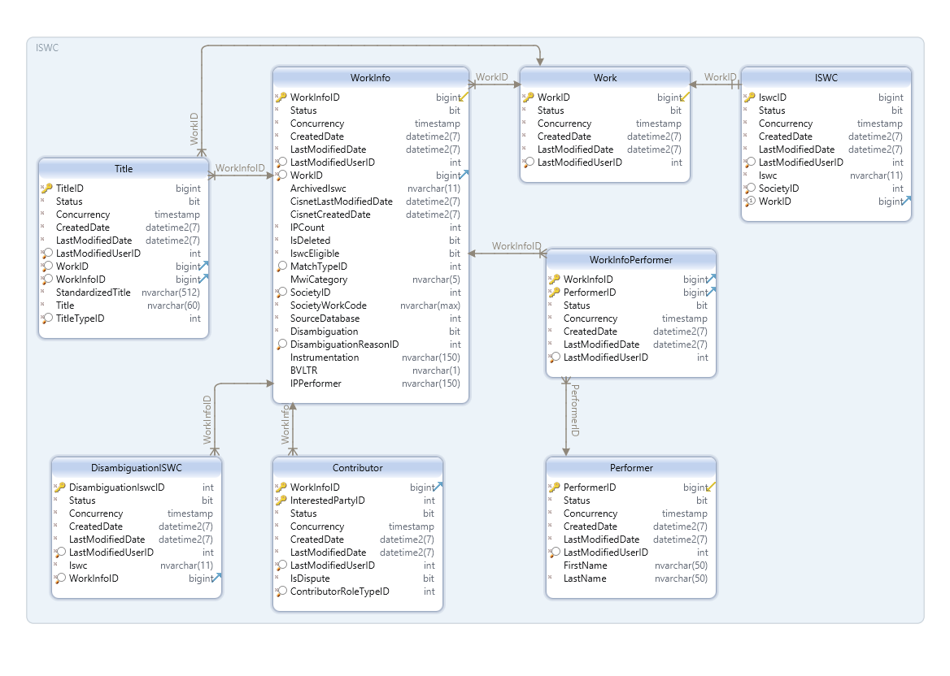

The new ISWC schema has largely preserved the Core schema from the existing database, with the addition of the following changes:

* DisambiguationISWC table to store additional disambiguating ISWCs that are submitted by a society
* Additional fields on the WorkInfo table to store the disambiguation data, including Instrumentation, BVLTR and IPPerformer

The reason for this was to ensure the data conversion process is straightforward while ensuring that the new system benefits from the new functionality.

The following are the tables in this schema. The Descriptions shown will be included in the database schema so can be used for reporting.

## Work

The Work table contains the base meta-data for a work. The following are the fields in the [ISWC].[Work] table.

|  |  |  |  |
| --- | --- | --- | --- |
| **Column** | **Data Type** | **Required** | **Description** |
| WorkID | Bigint | Yes | Work identifier |
| Status | Bit | Yes | Logically deleted status |
| Concurrency | Timestamp | Yes | Row version field |
| CreatedDate | Datetime2 | Yes | Date that the entity instance was created |
| LastModifiedDate | Datetime2 | Yes | Date of last modification |
| LastModifiedUserID | Int | Yes | The last modifying user |

Sample record from existing data model:

|  |  |  |  |  |
| --- | --- | --- | --- | --- |
| **WorkID** | **Status** | **CreatedDate** | **LastModifiedDate** | **LastModifiedUserID** |
| 6902258987 | 1 | 2019-01-14 23:58:46 | 2019-01-14 23:58:46 | AGENT |

**SELECT** work_id**,** 1 **as** Status**,** created_dt**,** last_updated_dt**,** last_updated_user **FROM** csi_works **WHERE** work_id**=**6902258987**;**

## ISWC

The ISWC table contains the ISWC record for a Work. The following are the fields in the [ISWC].[ISWC] table.

|  |  |  |  |
| --- | --- | --- | --- |
| **Column** | **Data Type** | **Required** | **Description** |
| IswcID | Bigint | Yes | ISWC unique identifier |
| Status | Bit | Yes | Logically deleted status |
| Concurrency | Timestamp | Yes | Row version field |
| CreatedDate | Datetime2 | Yes | Date that the entity instance was created |
| LastModifiedDate | Datetime2 | Yes | Date of last modification |
| LastModifiedUserID | Int | Yes | The last modifying user |
| Iswc | Nvarchar(11) | Yes | ISWC code |
| SocietyID | Int | Yes | CISAC society code reference |
| WorkID | Bigint | Yes | Work unique identifier reference |

Sample record from existing data model including key fields:

|  |  |  |  |  |  |
| --- | --- | --- | --- | --- | --- |
| **IswcID** | **CreatedDate** | **LastModifiedDate** | **Iswc** | **SocietyID** | **WorkID** |
| 6907676587 | 2019-01-14 23:58:46 | 2019-01-14 23:58:46 | T9272914359 | 315 | 6902258987 |

**SELECT** iswc_id**,** created_dt**,** last_updated_dt**,** iswc**,** society_code**,** work_id **FROM** csi_iswc **WHERE** work_id**=**6902258987**;**

## WorkInfo

The WorkInfo table contains the society submitted work records. The following are the fields in the [ISWC].[WorkInfo] table.

|  |  |  |  |
| --- | --- | --- | --- |
| **Column** | **Data Type** | **Required** | **Description** |
| WorkInfoID | Bigint | Yes | Work Info identifier |
| Status | Bit | Yes | Logically deleted status |
| Concurrency | Timestamp | Yes | Row version field |
| CreatedDate | Datetime2 | Yes | Date that the entity instance was created |
| LastModifiedDate | Datetime2 | Yes | Date of last modification |
| LastModifiedUserID | Int | Yes | The last modifying user |
| WorkID | Bigint | Yes | Work unique identifier reference |
| ArchivedIswc | Nvarchar(11) | No | Archived ISWC |
| CisnetLastModifiedDate | Datetime2 | No | Date of last modification on CIS-Net |
| CisnetCreatedDate | Datetime2 | No | Date of creation on CIS-Net |
| IPCount | Int | Yes | Number of IPs submitted |
| IsDeleted | Bit | Yes | Flag indicating society posting status |
| IswcEligible | Bit | Yes | Flag indicating eligibility |
| MatchTypeID | Int | No | Matching rule applied |
| MwiCategory | Nvarchar(5) | No | Work category from CIS-Net |
| SocietyID | Int | Yes | CISAC society code reference |
| SocietyWorkCode | Nvarchar(20) | Yes | CISAC society provided Work Code |
| SourceDatabase | Int | Yes | Source database |
| Disambiguation | Bit | Yes | Flag to indicate if disambiguation data was included in the submission |
| DisambiguationReasonID | Int | No | Disambiguation data type |
| Instrumentation | Nvarchar(150) | No | Instrumentation if provided |
| BVLTR | Nvarchar(1) | No | Background, Logo, Theme, Visual and Rolled Up Cue if provided |
| IPPerformer | Nvarchar(150) | No | IP Performer if provided |

Sample record from existing data model including key fields:

|  |  |  |  |  |  |
| --- | --- | --- | --- | --- | --- |
| **WorkInfoID** | **IPCount** | **IswcEligible** | **SocietyID** | **SocietyWorkCode** | **SourceDatabase** |
| 11886414285 | 1 | Y | 21 | 017417509 | 21 |

**SELECT** work_info_id**,** ip_count**,** iswc_eligible**,** society_code**,** society_work_code**,** source_db **FROM** csi_workinfo **WHERE** work_id**=**6902258987**;**

## Title

The Title table contains any associated titles with a work. The following are the fields in the [ISWC].[Title] table.

|  |  |  |  |
| --- | --- | --- | --- |
| **Column** | **Data Type** | **Required** | **Description** |
| TitleID | Bigint | Yes | Title unique identifier reference |
| Status | Bit | Yes | Logically deleted status |
| Concurrency | Timestamp | Yes | Row version field |
| CreatedDate | Datetime2 | Yes | Date that the entity instance was created |
| LastModifiedDate | Datetime2 | Yes | Date of last modification |
| LastModifiedUserID | Int | Yes | The last modifying user |
| WorkID | Bigint | Yes | Work identifier reference |
| WorkInfoID | Bigint | Yes | Work info identifier reference |
| StandardizedTitle | Nvarchar(512) | Yes | Standardized title |
| Title | Nvarchar(60) | Yes | Raw title |
| TitleTypeID | Int | Yes | Title Type identifier reference |

Sample record from existing data model including key fields:

|  |  |  |  |  |
| --- | --- | --- | --- | --- |
| **TitleID** | **WorkID** | **StandardizedTitle** | **Title** | **TitleTypeID** |
| 8628224314 | 6902258987 | THEORIAPRODBYSHELBYANTHONY | THEORIA PROD BY SHELBY ANTHONY | OT |

**SELECT** title_id**,** work_id**,** work_info_id**,** s_title**,** title**,** type_code

**FROM** csi**.**csi_titles **WHERE** work_id**=**6902258987**;**

## DisambiguationISWC

The DisambiguationISWC table contains any disambiguating ISWCs that may be sent by a society during a work submission. The following are the fields in the [ISWC].[DisambiguationISWC] table.

|  |  |  |  |
| --- | --- | --- | --- |
| **Column** | **Data Type** | **Required** | **Description** |
| DisambiguationIswcID | Int | Yes | Disambiguation ISWC unique identifier |
| Status | Bit | Yes | Logically deleted status |
| Concurrency | Timestamp | Yes | Row version field |
| CreatedDate | Datetime2 | Yes | Date that the entity instance was created |
| LastModifiedDate | Datetime2 | Yes | Date of last modification |
| LastModifiedUserID | Int | Yes | The last modifying user |
| Iswc | Nvarchar(11) | Yes | Disambiguation ISWC |
| WorkInfoID | Bigint | Yes | Work info identifier reference |

## Contributor

The Contributor table stores any contributors, either writer or publisher, on a work. The following are the fields in the [ISWC].[Contributor] table.

|  |  |  |  |
| --- | --- | --- | --- |
| **Column** | **Data Type** | **Required** | **Description** |
| InterestedPartyID | Int | Yes | Interested party identifier reference |
| WorkInfoID | Bigint | Yes | Work info identifier reference |
| Status | Bit | Yes | Logically deleted status |
| Concurrency | Timestamp | Yes | Row version field |
| CreatedDate | Datetime2 | Yes | Date that the entity instance was created |
| LastModifiedDate | Datetime2 | Yes | Date of last modification |
| LastModifiedUserID | Int | Yes | The last modifying user |
| IsDispute | Bit | Yes | Contributor is in dispute |
| ContributorRoleTypeID | Int | Yes | Contributor role type |

Sample record from existing data model including key fields:

|  |  |  |  |
| --- | --- | --- | --- |
| **InterestedPartyID** | **WorkInfoID** | **IsDispute** | **ContributorRoleTypeID** |
| 1 | 11886414285 | N | C |

**SELECT** 1**,** w**.**work_info_id**,** t1**.**dispute**,** t1**.**ip_role_code **FROM** csi_workinfo w **join** csi_workinfo_ip t1 **on** w**.**work_info_id **=** t1**.**work_info_id **WHERE** work_id**=**6902258987**;**

## Performer

The Performer table stores the full list of performers in the database. The following are the fields in the [ISWC].[Performer] table.

|  |  |  |  |
| --- | --- | --- | --- |
| **Column** | **Data Type** | **Required** | **Description** |
| PerformerID | Bigint | Yes | Work info performer identifier |
| Status | Bit | Yes | Logically deleted status |
| Concurrency | Timestamp | Yes | Row version field |
| CreatedDate | Datetime2 | Yes | Date that the entity instance was created |
| LastModifiedDate | Datetime2 | Yes | Date of last modification |
| LastModifiedUserID | Int | Yes | The last modifying user |
| FirstName | Nvarchar(50) | No | First name of performer |
| LastName | Nvarchar(50) | Yes | Last name of performer |

Sample record from existing data model including key fields:

|  |  |  |
| --- | --- | --- |
| **PerformerID** | **FirstName** | **LastName** |
| 27174506 |  | AARON ELIYAH |

**select** perf**.**perf_id**,** perf**.**fstname**,** perf**.**lstname **from** csi_workinfo_performer p

**join** csi_workinfo wi **on** p**.**work_info_id**=**wi**.**work_info_id

**join** csi_performer perf **on** perf**.**perf_id**=**p**.**perf_id

**where** work_id**=**6902258987**;**

## WorkInfoPerformer

The WorkInfoPerformer table stores the link between a work and its associated performers. The following are the fields in the [ISWC].[WorkInfoPerformer] table.

|  |  |  |  |
| --- | --- | --- | --- |
| **Column** | **Data Type** | **Required** | **Description** |
| WorkInfoID | Bigint | Yes | Work info unique identifier reference |
| PerformerID | Bigint | Yes | Performer unique identifier reference |
| Status | Bit | Yes | Logically deleted status |
| Concurrency | Timestamp | Yes | Row version field |
| CreatedDate | Datetime2 | Yes | Date that the entity instance was created |
| LastModifiedDate | Datetime2 | Yes | Date of last modification |
| LastModifiedUserID | Int | Yes | The last modifying user |

1. IPI Schema

The IPI schema contains the SUISA IPI data. The following is an ER diagram for the ISWC schema:

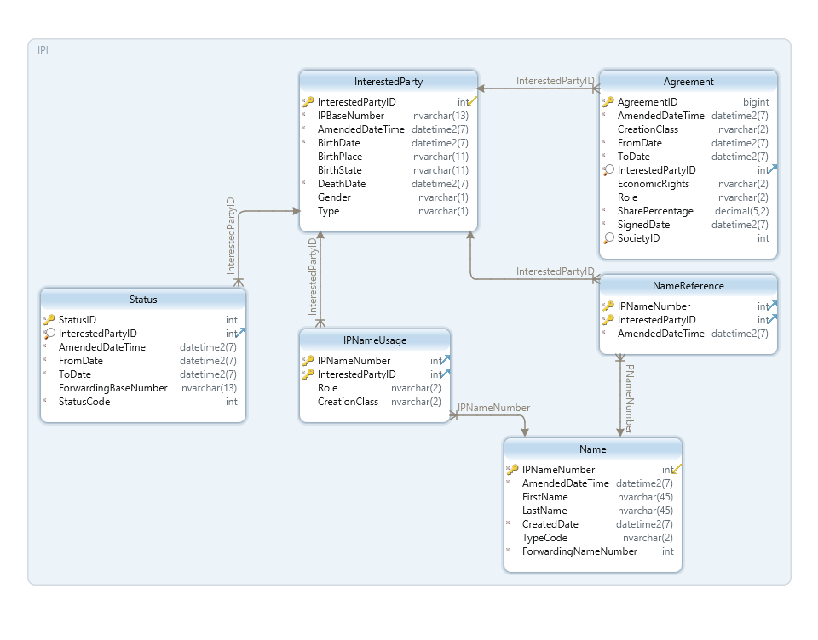

The following change has been made to the IPI schema from the existing ISWC data model:

* The BirthDate and DeathDate fields have been consolidated from the existing data model, which split out these fields into their constituent parts.

The following are the tables in this schema:

## InterestedParty

The InterestedParty table contains the base data for an IP. The following are the fields in the [IPI].[InterestedParty] table.

|  |  |  |  |
| --- | --- | --- | --- |
| **Column** | **Data Type** | **Required** | **Description** |
| InterestedPartyID | Int | Yes | Interested party identifier |
| IPBaseNumber | Nvarchar(13) | Yes | Interested party base number |
| AmendedDateTime | Datetime2 | Yes | Amended date/time |
| BirthDate | Datetime2 | No | Birth date |
| BirthPlace | Nvarchar(11) | No | Birth place |
| BirthState | Nvarchar(11) | No | Birth state |
| DeathDate | Datetime2 | No | Death date |
| Gender | Nvarchar(1) | No | Gender |
| Type | Nvarchar(1) | Yes | Interested party type |

Sample record from existing data model including key fields:

|  |  |  |  |  |  |  |
| --- | --- | --- | --- | --- | --- | --- |
| **InterestedPartyID** | **IPBaseNumber** | **BirthDate** | **DeathDate** | **BirthPlace** | **Gender** | **Type** |
| 1 | I-000000015-5 | 1918-01-07 | 2009-09-08 |  | F | N |

**select** 1**,** ipbasenr**,** make_date**(cast(**birthyy **as** **int),** **cast(**birthmm **as** **int),** **cast(**birthdd **as** **int)),** make_date**(cast(**deathyy **as** **int),** **cast(**deathmm **as** **int),** **cast(**deathdd **as** **int)),** birthplace**,** gender**,** iptyp

**FROM** ipir**.**ipi_basedat

**where** ipbasenr **=** 'I-000000015-5'**;**

## Agreement

The Agreement table contains the associated agreements with interested parties. The following are the fields in the [IPI].[Agreement] table.

|  |  |  |  |
| --- | --- | --- | --- |
| **Column** | **Data Type** | **Required** | **Description** |
| AgreementID | Bigint | Yes | Membership agreements identifier |
| AmendedDateTime | Datetime2 | Yes | Amended date/time |
| CreationClass | Nvarchar(2) | Yes | Creation class |
| FromDate | Datetime2 | Yes | Date/time of commencement |
| ToDate | Datetime2 | Yes | Date/time of termination |
| InterestedPartyID | Int | Yes | Interested party reference |
| EconomicRights | Nvarchar(2) | Yes | Economic rights |
| Role | Nvarchar(2) | Yes | Role within the creation class |
| SharePercentage | Decimal(5,2) | Yes | Share percentage |
| SignedDate | Datetime2 | No | Agreement date/time of sign off |
| SocietyID | Int | Yes | Society of membership |

## Name

The Name table contains the IPNameNumber and names of interested parties. The following are the fields in the [IPI].[Name] table.

|  |  |  |  |
| --- | --- | --- | --- |
| **Column** | **Data Type** | **Required** | **Description** |
| IPNameNumber | Int | Yes | Interested party name number |
| AmendedDateTime | Datetime2 | Yes | Amended date/time |
| FirstName | Nvarchar(45) | No | First name |
| LastName | Nvarchar(45) | No | Last name |
| CreatedDate | Datetime2 | Yes | Date/time the name entry was created |
| TypeCode | Nvarchar(2) | No | Type of name entry |
| ForwardingNameNumber | Int | Yes | Forwarding name number |

## IPNameUsage

The IPNameUsage table contains the role of the interested party, linking the interested party table and the name table. The following are the fields in the [IPI].[IPNameUsage] table.

|  |  |  |  |
| --- | --- | --- | --- |
| **Column** | **Data Type** | **Required** | **Description** |
| IPNameNumber | Int | Yes | Interested party name number reference |
| InterestedPartyID | Int | Yes | Interested party reference |
| Role | Nvarchar(2) | No | Role within the creation class |
| CreationClass | Nvarchar(2) | No | Creation class |

## NameReference

The NameReference table contains the link between the interested party table and the name table. The following are the fields in the [IPI].[NameReference] table.

|  |  |  |  |
| --- | --- | --- | --- |
| **Column** | **Data Type** | **Required** | **Description** |
| IPNameNumber | Int | Yes | Interested party name number reference |
| InterestedPartyID | Int | Yes | Interested party reference |
| AmendedDateTime | Datetime2 | Yes | Amended date/time |

## Status

The Status table contains the status of the interested party between certain dates. The following are the fields in the [IPI].[Status] table.

|  |  |  |  |
| --- | --- | --- | --- |
| **Column** | **Data Type** | **Required** | **Description** |
| StatusID | Int | Yes | Status identifier |
| InterestedPartyID | Int | Yes | Interested party reference |
| AmendedDateTime | Datetime2 | Yes | Amended date/time |
| FromDate | Datetime2 | Yes | Date/time of commencement |
| ToDate | Datetime2 | Yes | Date/time of termination |
| ForwardingBaseNumber | Nvarchar(13) | Yes | Forwarding base number |
| StatusCode | Int | Yes | Status of base number |

1. Lookup Schema

The Lookup schema contains reference data for the ISWC and IPI database schemas. The following is an ER diagram for the Lookup schema:

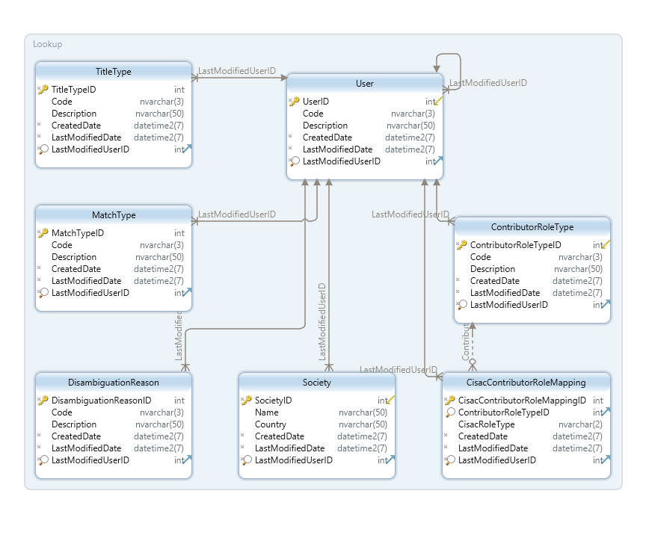

The following are the tables in this schema:

## ContributorRoleType

The ContributorRoleType tables stores the contributor role types. The following are the fields in the [Lookup].[ContributorRoleType] table.

|  |  |  |  |
| --- | --- | --- | --- |
| **Column** | **Data Type** | **Required** | **Description** |
| ContributorRoleTypeID | Int | Yes | Contributor role type identifier |
| Code | Nvarchar(3) | Yes | Entity instance code |
| Description | Nvarchar(50) | Yes | Entity instance description |
| CreatedDate | Datetime2 | Yes | Date that the entity instance was created |
| LastModifiedDate | Datetime2 | Yes | Date of last modification |
| LastModifiedUserID | Int | Yes | The last modifying user |

## CisacContributorRoleMapping

The CisacContributorRoleMapping table stores the mapping between the CISAC contributor roles and the Contributor roles. The following are the fields in the [Lookup].[CisacContributorRoleMapping] table.

|  |  |  |  |
| --- | --- | --- | --- |
| **Column** | **Data Type** | **Required** | **Description** |
| CisacContributorRoleMappingID | Int | Yes | CISAC contributor role mapping ID |
| ContributorRoleTypeID | Int | Yes | Internal CSI role type |
| CisacRoleType | Nvarchar(2) | Yes | CISAC role type |
| CreatedDate | Datetime2 | Yes | Date that the entity instance was created |
| LastModifiedDate | Datetime2 | Yes | Date of last modification |
| LastModifiedUserID | Int | Yes | The last modifying user |

## DisambiguationReason

The DisambiguationReason table stores the possible values for disambiguation reasons. The following are the fields in the [Lookup].[DisambiguationReason] table.

|  |  |  |  |
| --- | --- | --- | --- |
| **Column** | **Data Type** | **Required** | **Description** |
| DisambiguationReasonID | Int | Yes | Disambiguation reason identifier |
| Code | Nvarchar(3) | Yes | Entity instance code |
| Description | Nvarchar(50) | Yes | Entity instance description |
| CreatedDate | Datetime2 | Yes | Date that the entity instance was created |
| LastModifiedDate | Datetime2 | Yes | Date of last modification |
| LastModifiedUserID | Int | Yes | The last modifying user |

## MatchType

The MatchType table stores the possible values for match types. The following are the fields in the [Lookup].[MatchType] table.

|  |  |  |  |
| --- | --- | --- | --- |
| **Column** | **Data Type** | **Required** | **Description** |
| MatchTypeID | Int | Yes | Match type identifier |
| Code | Nvarchar(3) | Yes | Entity instance code |
| Description | Nvarchar(50) | Yes | Entity instance description |
| CreatedDate | Datetime2 | Yes | Date that the entity instance was created |
| LastModifiedDate | Datetime2 | Yes | Date of last modification |
| LastModifiedUserID | Int | Yes | The last modifying user |

## Society

The Society table stores the full list of societies in the database. The following are the fields in the [Lookup].[Society] table.

|  |  |  |  |
| --- | --- | --- | --- |
| **Column** | **Data Type** | **Required** | **Description** |
| SocietyID | Int | Yes | Society identifier |
| Name | Nvarchar(50) | Yes | Society name |
| Country | Nvarchar(50) | No | Country |
| CreatedDate | Datetime2 | Yes | Date that the entity instance was created |
| LastModifiedDate | Datetime2 | Yes | Date of last modification |
| LastModifiedUserID | Int | Yes | The last modifying user |

## TitleType

The TitleType table stores the possible values for title types. The following are the fields in the [Lookup].[TitleType] table.

|  |  |  |  |
| --- | --- | --- | --- |
| **Column** | **Data Type** | **Required** | **Description** |
| TitleTypeID | Int | Yes | Title type identifier |
| Code | Nvarchar(3) | Yes | Entity instance code |
| Description | Nvarchar(50) | Yes | Entity instance description |
| CreatedDate | Datetime2 | Yes | Date that the entity instance was created |
| LastModifiedDate | Datetime2 | Yes | Date of last modification |
| LastModifiedUserID | Int | Yes | The last modifying user |

## User

The User table stores the list of possible users. The following are the fields in the [Lookup].[User] table.

|  |  |  |  |
| --- | --- | --- | --- |
| **Column** | **Data Type** | **Required** | **Description** |
| UserID | Int | Yes | User identifier |
| Code | Nvarchar(3) | Yes | Entity instance code |
| Description | Nvarchar(50) | Yes | Entity instance description |
| CreatedDate | Datetime2 | Yes | Date that the entity instance was created |
| LastModifiedDate | Datetime2 | Yes | Date of last modification |
| LastModifiedUserID | Int | Yes | The last modifying user |

1. Audit Schema

The Audit schema contains the audit data and is stored in Cosmos DB. Data in Cosmos DB is stored as collections of JSON objects. A collection is the equivalent of a table in an SQL database. The following is an ER diagram for the logical grouping of the collections:

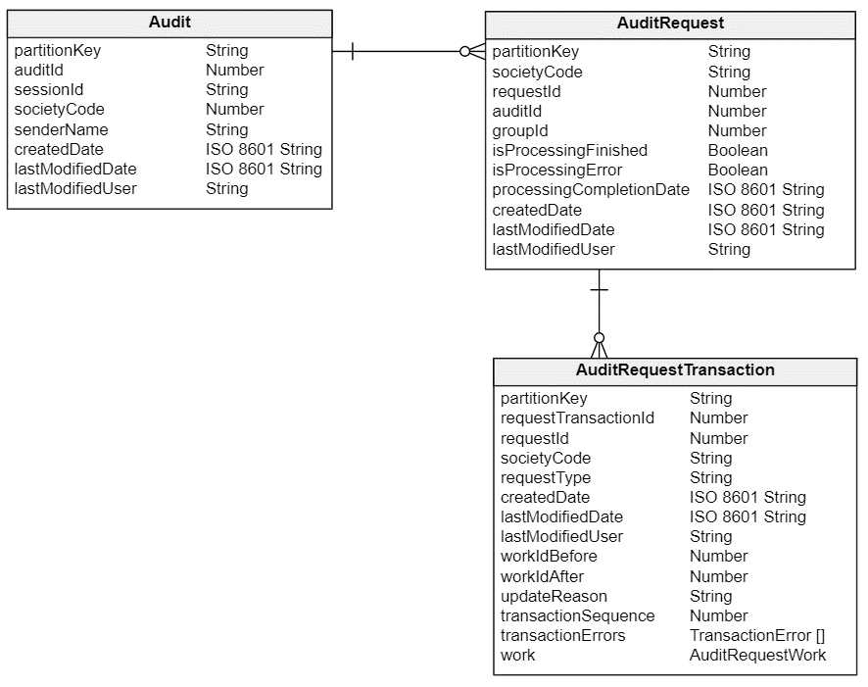

The following are the collections in this schema:

## Audit

The Audit collection stores the top-level log data for a submission. The following are the fields in the [Audit] collection.

|  |  |  |  |
| --- | --- | --- | --- |
| **Field** | **Data Type** | **Required** | **Description** |
| partitionKey | String | Yes | Used to sort the records into partitions. Will be formatted as XXXDDD where XXX is the SocietyCode and DDD the month of the CreatedDate e.g. Society 222 and Created Date in January gives PK = 2221 |
| auditId | Number | Yes | Audit identifier |
| sessionId | String | Yes | Session identifier |
| societyCode | Number | Yes | CISAC society identifier |
| senderName | String | Yes | Internal system sender identifier |
| createdDate | ISO 8601 String | Yes | Date that the entity instance was created |
| lastModifiedDate | ISO 8601 String | Yes | Date of last modification |
| lastModifiedUser | String | Yes | The last modifying user |

Sample record from existing data model including key fields:

**{**

"partitionKey"**:** "351"**,**

"auditId"**:** 8700795503**,**

"sessionId"**:** "01012019163127-sync"**,**

"societyCode"**:** 35**,**

"senderName"**:** "WEBSERVICE"**,**

"createdDate"**:** "2019-01-01T16:31:27.000Z"**,**

"lastModifiedDate"**:** "2019-01-01T16:31:27.000Z"**,**

"lastModifiedUser"**:** "WEBSERVICE"

**}**

**select** **\*** **from** csi_audit **where** audit_id **=** 8700795503

## AuditRequest

The AuditRequest collection stores the log data for individual requests. The following are the fields in the [AuditRequest] collection.

|  |  |  |  |
| --- | --- | --- | --- |
| **Field** | **Data Type** | **Required** | **Description** |
| partitionKey | String | Yes | Used to sort the records into partitions. Will be formatted as XXXDDD where XXX is the SocietyCode and DDD the month of the CreatedDate e.g. Society 222 and Created Date in January gives PK = 2221 |
| requestId | Number | Yes | Request identifier |
| auditId | Number | Yes | Audit identifier reference |
| recordId | Number | Yes | Record number in the batch |
| groupId | Number | Yes | Request group identifier |
| societyCode | String | Yes | CISAC society identifier |
| isProcessingFinished | Boolean | No | Flag for processing completion |
| isProcessingError | Boolean | No | Flag for processing error |
| processingCompletionDate | ISO 8601 String | No | Date processing completed |
| createdDate | ISO 8601 String | Yes | Date that the entity instance was created |
| lastModifiedDate | ISO 8601 String | Yes | Date of last modification |
| lastModifiedUser | String | Yes | The last modifying user |

Sample record from existing data model including key fields:

**{**

"partitionKey"**:** "351"**,**

"requestId"**:** 33704768964**,**

"auditId"**:** 8700795503**,**

"recordId"**:** 1**,**

"groupId"**:** 1**,**

"societyCode"**:** 35**,**

"isProcessingFinished"**:** **true,**

"isProcessingError"**:** **true,**

"processingCompletionDate"**:** "2019-01-01T16:31:27.000Z"**,**

"createdDate"**:** "2019-01-01T16:31:27.000Z"**,**

"lastUpdatedDate"**:** "2019-01-01T16:31:27.000Z"**,**

"lastUpdatedUser"**:** "WEBSERVICE"

**}**

**select** **\*** **from** csi_audit_req **where** audit_id **=** 8700795503

## AuditRequestTransaction

The AuditRequestTransaction collection stores the log data for individual transactions. The following are the fields in the [AuditRequestTransaction] collection.

|  |  |  |  |
| --- | --- | --- | --- |
| **Field** | **Data Type** | **Required** | **Description** |
| partitionKey | String | Yes | Used to sort the records into partitions. Will be formatted as XXXDDD where XXX is the SocietyCode and DDD the month of the CreatedDate e.g. Society 222 and Created Date in January gives PK = 2221 |
| requestTransactionId | Number | Yes | Request Transaction identifier |
| requestId | Number | Yes | Request identifier reference |
| societyCode | String | Yes | CISAC society identifier |
| requestType | String | Yes | Request transaction type |
| createdDate | ISO 8601 String | Yes | Date that the entity instance was created |
| lastModifiedDate | ISO 8601 String | Yes | Date of last modification |
| lastModifiedUser | String | Yes | The last modifying user |
| workIdBefore | Number | No | Work Info identifier reference before transaction completes |
| workIdAfter | Number | No | Work Info identifier reference after transaction completes |
| updateReason | Number | No | Update reason |
| transactionSequence | Number | Yes | Transaction sequence number |
| transactionErrors | Array of TransactionError | No | Array of any transaction errors |
| work | AuditRequestWork | Yes | Work details of transaction |

Sample record from existing data model including key fields:

**{**

"partitionKey"**:** "351"**,**

"requestTransactionId"**:** 888864052**,**

"requestId"**:** 33704768964**,**

"requestType"**:** "CAR"**,**

"createdDate"**:** "2019-01-01T16:31:27.000Z"**,**

"lastUpdatedDate"**:** "2019-01-01T16:31:27.000Z"**,**

"lastUpdatedUser"**:** "WEBSERVICE"**,**

"workIdAfter"**:** **null,**

"workIdBefore"**:** **null,**

"updateReason"**:** **null,**

"transactionSequence"**:** 0**,**

"transactionErrors"**:** **[**

**{**

"errorReasonCode"**:** "2014.1000"**,**

"errorData"**:** ""**,**

"createdDate"**:** "2019-01-01T16:31:27.000Z"**,**

"lastUpdatedDate"**:** "2019-01-01T16:31:27.000Z"**,**

"lastUpdatedUser"**:** "WEBSERVICE"

**}**

**],**

"work"**:** **{**

"societyWorkCode"**:** "19026297-001"**,**

"sourceDb"**:** 35**,**

"society"**:** 35**,**

"submittedISWC"**:** ""**,**

"preferredISWC"**:** ""**,**

"category"**:** "DOM"**,**

"isDeleted"**:** **false,**

"postedDate"**:** **null,**

"createdDate"**:** "2019-01-01T16:31:27.000Z"**,**

"lastUpdatedDate"**:** "2019-01-01T16:31:27.000Z"**,**

"lastUpdatedUser"**:** "WEBSERVICE"**,**

"titles"**:** **[],**

"contributors"**:** **[]**

**}**

**}**

**select** tx**.*,** er**.*,** w**.\*** **from** csi_audit_req req

**join** csi_audit_req_tx tx **on** req**.**req_id **=** tx**.**req_id

**join** csi_audit_req_tx_error er **on** tx**.**req_tx_id **=** er**.**req_tx_id

**join** csi_audit_req_work w **on** w**.**req_tx_id **=** tx**.**req_tx_id

**where** audit_id **=** 8700795503

### AuditRequestTransactionError object definition

The following are the fields in the [AuditRequestTransactionError] object:

|  |  |  |  |
| --- | --- | --- | --- |
| **Field** | **Data Type** | **Required** | **Description** |
| errorReasonCode | String | Yes | Exception code |
| errorData | String | No | Associated meta-data with the error |
| createdDate | ISO 8601 String | Yes | Date that the entity instance was created |
| lastModifiedDate | ISO 8601 String | Yes | Date of last modification |
| lastModifiedUser | String | Yes | The last modifying user |

### AuditRequestWork object definition

The following are the fields in the [AuditRequestWork] object:

|  |  |  |  |
| --- | --- | --- | --- |
| **Field** | **Data Type** | **Required** | **Description** |
| societyWorkCode | String | No | Submitting society work code |
| sourceDb | Number | No | Society code for source database |
| society | Number | No | Submitting society |
| submittedISWC | String | No | Submitted ISWC |
| preferredISWC | String | No | Preferred ISWC at point in time |
| category | String | No | CIS-Net work category |
| isDeleted | Boolean | No | Flag work deletion status of work |
| postedDate | ISO 8601 String | No | Date that the work was posted in CIS-Net |
| createdDate | ISO 8601 String | Yes | Date that the entity instance was created |
| lastModifiedDate | ISO 8601 String | Yes | Date of last modification |
| lastModifiedUser | String | Yes | The last modifying user |
| titles [] | JSON | No | Title JSON data |
| contributors [] | JSON | No | Contributor JSON data |

1. ISWC (Cosmos DB)

The ISWC schema that is stored in Cosmos DB will contain a single collection called ISWC. This collection will store the next value of the ISWC to be issued.

## ISWC

The following are the fields in the [ISWC] collection.

|  |  |  |  |
| --- | --- | --- | --- |
| **Field** | **Data Type** | **Required** | **Description** |
| iswc | String | Yes | Next value of ISWC to be issued |

1. Matching Engine Schema

The Spanish Point Matching Engine comprises of two schemas: Azure Search Indices and an SQL database.

The Core Matching Engine has a work name and connected party index. This includes titles, creators, publishers and performers and a number index including ISWCs and society work numbers. Once the business rules are defined, then the exact fields that are synchronized to the index will be finalized.

## Azure Search Indices

The following are the indices that will be created:

### Work Numbers

The WorkNumbers index contains all work numbers from the SQL database including ISWCs and Society work numbers. The following are the fields in this index.

|  |  |  |  |
| --- | --- | --- | --- |
| **Column** | **Data Type** | **Required** | **Description** |
| GeneratedID | String | Yes | Autogenerated identifier |
| WorkCode | Int | Yes | Mapped from ISWC.Work.WorkID |
| TypeCode | String | Yes | Mapped from ISWC.WorkInfo.SocietyID or “ISWC” |
| Number | String | Yes | Mapped from ISWC.WorkInfo.SocietyWorkCode or ISWC.ISWC.Iswc |
| IsDeleted | Boolean | Yes | Logically deleted status of entity |

### Work Name, Contributors, Performers

The Repertoire-Work Name, Contributors, Performers index contains all work titles, contributors and performers from the SQL database. The following are the fields in this index.

|  |  |  |  |
| --- | --- | --- | --- |
| **Column** | **Data Type** | **Required** | **Description** |
| GeneratedID | String | Yes | Autogenerated identifier |
| WorkCode | Int | Yes | Mapped from ISWC.Work.WorkID |
| WorkName | String | Yes | Mapped from ISWC.Title.Title |
| WorkNameType | Int | Yes | Mapped from ISWC.Title.TitleTypeID |
| PersonID | Int | Yes | Mapped from either ISWC.Contributor.WorkInfoID or ISWC.Performer.PerformerID |
| Name | String | Yes | Mapped from IPI.Name.LastName |
| PersonType | Int | Yes | Mapped from whether the record is a Performer or Contributor Type |
| ContributorType | Int | Yes | Mapped from ISWC.Contributor.ContributorRoleTypeID |
| IsDeleted | Boolean | Yes | Logically deleted status of entity |
| IPINumber | String | Yes | Mapped from IPI.Name.IPINameNumber |

## Matching Settings Database

An SQL Azure database contains the matching rules parameters. This database contains all configurable rules for the matching engine. Any updates to this existing schema will be defined after the To Be Business Rules are finalized.

# Appendix A – Open and Closed Items

This appendix provides a tracking list of specific issues/queries raised by CISAC during the specification process and how they were incorporated or excluded from this specification:

|  |  |  |  |  |
| --- | --- | --- | --- | --- |
| **Open and Closed Items** | | | | |
| **ID** | **Description** | **Response** | **Status** | **Next Action By** |
| 1 | In the existing data model, the work contributors for a work are linked to a single record in the csi_workinfo table. Is there a reason for this or can we link the work contributors directly to the Work table in the new data model?  Sample query to show the issue: **select** * **from** csi_workinfo wi  **join** csi_workinfo_ip ip **on** ip.work_info_id=wi.work_info_id  **where** work_id=378 |  |  |  |
|  |  |  |  |  |
|  |  |  |  |  |
|  |  |  |  |  |
|  |  |  |  |  |
|  |  |  |  |  |
|  |  |  |  |  |
|  |  |  |  |  |
|  |  |  |  |  |
|  |  |  |  |  |